Peer reviews – some suggested guidelines

Thank you for helping BRACE by reviewing a research proposal the charity has received. Independent peer reviews are essential to our work and we are very grateful for the gift of your time and expertise.

Please check our Conflicts of Interest policy to ensure that there is nothing to prevent your review being considered.

BRACE does not have a standard review form, preferring to allow reviewers the freedom to assess proposals in their own way.

However the Scientific Advisory Committee has suggested that reviewers might keep the following questions in mind:

With regard to the proposed project:

- Is there a clear, testable and novel hypothesis?
- Does it have relevance to furthering our understanding of dementia?
- Has the relevant scientific literature been considered?
- And has that consideration been appropriate?
- Are the proposed experiments and their analysis appropriate and feasible?
- Will the experiments provide a good test of the hypothesis?
- Are the costs reasonable?
- Can the work be completed in the proposed timeframe?
- If animal testing is involved does it comply with 3R’s? (for further information please see: Responsibility in the use of animals in bioscience research. )

Please send the review in PDF or Word format to sac@alzheimers-brace.org

Thank you for your help.

Emma Bone
SAC Administrator
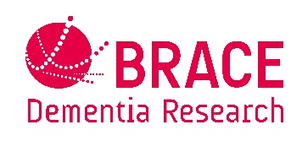
BRACE - Dementia Research The BRACE Charity Office Southmead Hospital Bristol BS10 5NB
Tel/Fax: 0117 414 4831 www.alzheimers-brace.org Reg charity no 297965

